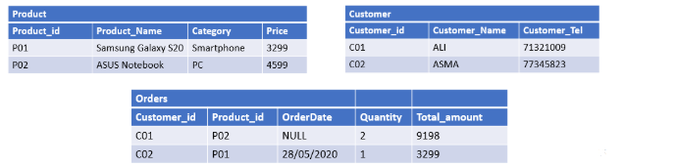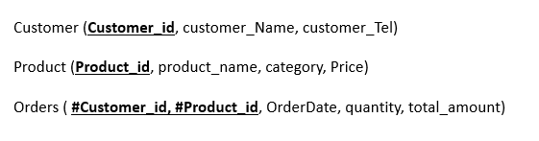

NSERT INTO Customer VALUES

(

(‘c01’,’ALI’,’71321009’),

(‘c02’,’ASMA’,’77345823’),

)

NSERT INTO Product VALUES

(

(‘P01’,’Sumsung Galaxy S20’,’Smartphone’,’3299’),

(‘P02’,’ASUS Notbook’,’PC’,’4599’)

)

NSERT INTO Orders VALUES

(

(‘c01’,’P02’,’ ‘,’2’,’9198’),

(‘c02’,’P02’,’28/05/2020’,’1’,’3299’)

)